Charles Cundiff
AE498 HW3

Github:

Question 1: Epoch One Summary
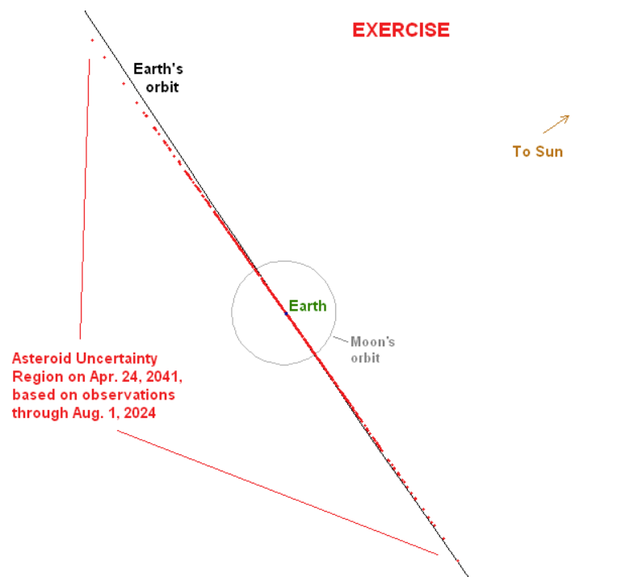
The 2025 PDC asteroid impact scenario was an exercise presented at the 2025 planetary defense conference. A new near-Earth asteroid was discovered on June 5, 2024 while it was distant (0.233 au) and getting farther from the Earth. The asteroid has a perihelion of 1 au and aphelion of 2.29 au with an inclination of 11 degrees. The size of the asteroid is bounded by JWST to between 50-280 m and most likely ~125 m and its content is largely silicon-based, or rocky.

The asteroid is predicted to have a 1.6% chance of hitting Earth on April 24, 2041. In this epoch, the uncertainty region for the time of potential impact is much longer than Earth’s diameter and is depicted to the right. Due to the size uncertainty, the impact energy is estimated to be between 5-70 Mt. Until the asteroid moves from the daytime sky to the nighttime sky in August 2025, the observations to update the probability of collision cannot be made.

Question 2: Initial Orbit Determination
Initial orbit determination was initially done with my own Gauss and Gibbs solver. Due to instability based on the chosen points and misalignment with the other sources though, this method was thrown out. Its inaccuracies are likely due to the short arc length of observations.
Initial orbit determination was then completed with Find Orb, a tool freely available online. This was used because it is highly accurate, producing results very similar to the ones provided in the example by Eggl. The Find Orb and Eggl initial solution is below. As you can see, they are highly similar.
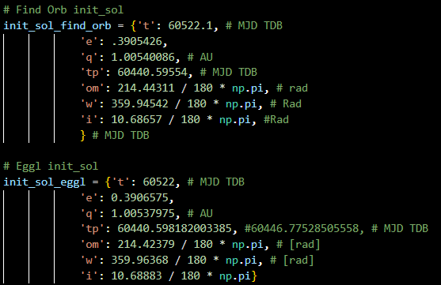

Question 3: Orbit Determination
Orbit determination as completed using the GRSS package. The guide given by Eggl’s example was followed. The initial covariance is 0.1 times the identity matrix. The initial final fitted mean and covariance are below.
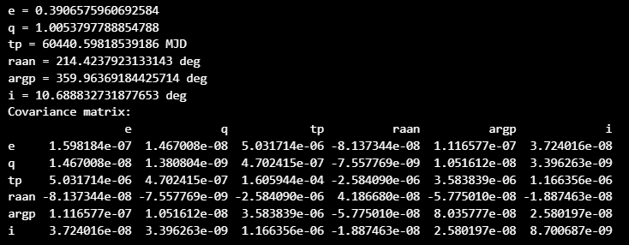

Question 4: Orbit and Covariance Matrix Propagation
The mean and covariance were propagated forward to April 24, 2041. This was done by Monte-Carlo selection of the mean and covariance from question 3. 100 samples were propagated forward and then the mean and covariance were solved at the target time. The propagated Monte-Carlo simulation is shown below. Clearly, the asteroid has a high risk of hitting Earth on this date as Earth is
